
Crimes in India Project Report



Submitted by: SIMRAN FAIZI

ACKNOWLEDGMENT
I would like to express my deepest gratitude to my Instructor Mr. Shankargouda Tegginmani as well as Data Trained Academy who gave me the opportunity to do this project on CRIMES IN INDIA, which also helped me in doing lots of research wherein I came to know about so many new things especially the data collection part.
Also, I have utilized a few external resources that helped me to complete the project. I ensured that I learn from the samples and modify things according to my project requirement. All the external resources that were used in creating this project are listed below:

1) https://www.prb.org/wp-content/uploads/2011/04/india-population-2001-2011.pdf
2) https://censusindia.gov.in/nada/index.php/catalog/20030
3) https://scikit-learn.org/stable/user_guide.html
4) https://github.com/
5) https://www.kaggle.com/
6) https://medium.com/
7) https://towardsdatascience.com/
8) https://www.analyticsvidhya.com/
9) https://www.geeksforgeeks.org/
10)https://www.latestlaws.com/wp-content/uploads/2018/07/National-Crime-Record-Bureau-Report-NCRB-2012.pdf

INTRODUCTION

- Project Problem Framing-
Crime – a term which is just like a havoc in today’s world. It is a disastrous act for entire humanity and an obstacle in the way of development. The legal definition of crime introduces us with a vast number of hardships and complexities as it is a social construction that we consider a crime.. It is disputed and contingent dynamically. In other words, crime differs over time and location. It is not a universally accepted factor and it's socially built and altered reality. Crime is just like a toxic which spoils the growth of a nation. Simply, a crime can be defined as a criminal offense against any person or an organization with an intent to harm them directly or indirectly that is illegal and punishable under the country law. Crimes like robberies, looting, sexual harassment, rape, abduction, and killings are one of the major crimes which are happening at a breakneck speed starting from rural to urban areas. As these crimes are lifting high and high so there is a need to control them and thus creating huge pressure on the investigation department. There should be a system which can analyze crime and police department can make use of this technology that can make their task easier to investigate the case on the basis of different trends for years. Crime analysis is a law enforcement technique that involves systematic analysis for trends and patterns identification and analysis.
- Review of Literature
This project is more about exploration Clustering that can be done on this data. Since we scrape huge amount of data that includes more crimes related features, we can do better data exploration and derive some interesting features using the available columns.
Analytical Problem Framing
- Mathematical/ Analytical Modeling of the Problem
In our dataset there are States/UT, Districts, Year and different heads f clrime total 37 columns I got in this dataset(phase 4) , Since there is no Target variable so we handle this Problem as Unsupervised Machine Learning and will use Clustering Algorithm
This project is done in two parts:
- Data Collection phase
- Clustering phase
Phase 1

- You can collect data from anywhere (wiki, google, etc) but mention the link from where data is being collected.4 The population of each state.
- Literacy Rate in each state
- Area of each state
- Collect any other data that helps with your analysis. There is no limitation for anything.
- Create a new file and keep the above-collected data.

Links that are being used for data collection-
- 0https://www.wbhealth.gov.in/other_files/2007/14_5.html
- https://en.wikipedia.org/wiki/List_of_states_and_union_territories_of_India_by_population
- https://www.kaggle.com/datasets/webaccess/india-census-yearly-data
- https://censusindia.gov.in/nada/index.php/catalog/20030

Phase 2:
After collecting the data,you need to Analyse the dataset.
- Analysis of Literacy Rate vs Total Crimes
- Analysis of the type of crime vs each state vs Literacy rate.
- Analysis of year-on-year total crime rate.
- Analysis of area vs overall crime
- Analysis of Population vs overall Crime
- Data Sources and their formats
The dataset is in the form of CSV (Comma Separated Value) format and consists of 48 columns with 420 number of records as explained below:

- State/UT: Each state present in india.
- Year : 2001 to 2012
- population(total)- total population of state or UT in each year from 2001 to 2012
- Rural : Population of Rural area of that state
- 'Urban :Population of urban area of that state,
- 'Tot_M' : Total population of Males present in that State/UT
- 'Tot_F' : Total population of Females present in that State/UT,
- 'P_LIT' - Total Literate population of each state,
- 'M_LIT' : Male literacy population of each state
- F_LIT : Female literate population in each state
- Lit_rate : Literacy Rate
- Area- Area in KM square of each state
- Murder- number of murder in each stae
- 'ATTEMPT TO MURDER',
- 'CULPABLE HOMICIDE NOT AMOUNTING TO MURDER',
- 'RAPE',
- 'CUSTODIAL RAPE',
- 'OTHER RAPE',
- 'KIDNAPPING & ABDUCTION',
- 'KIDNAPPING AND ABDUCTION OF WOMEN AND GIRLS',
- 'KIDNAPPING AND ABDUCTION OF OTHERS',
- 'DACOITY',
- 'PREPARATION AND ASSEMBLY FOR DACOITY',
- 'ROBBERY',
- 'BURGLARY',
- 'THEFT',
- 'AUTO THEFT',
- 'OTHER THEFT',
- 'RIOTS',
- 'CRIMINAL BREACH OF TRUST',
- 'CHEATING',
- 'COUNTERFIETING',
- 'ARSON',
- 'HURT/GREVIOUS HURT',
- 'DOWRY DEATHS',
- ASSAULT ON WOMEN WITH INTENT TO OUTRAGE HER MODESTY',
- 'INSULT TO MODESTY OF WOMEN',
- 'CRUELTY BY HUSBAND OR HIS RELATIVES',
- 'IMPORTATION OF GIRLS FROM FOREIGN COUNTRIES',
- 'CAUSING DEATH BY NEGLIGENCE',
- 'OTHER IPC CRIMES',
- 'TOTAL IPC CRIMES',
- 'Total Crimes',
- 'tot_crimes_sc': Total crimes against SC comitted in each year,
- 'total crime against women : Total crimes against Women comitted in each year,
- 'Total crimes against STs': Total crimes against STs comitted in each year,
- 'Total crime against children- Total crimes against Children comitted in each year
- Crime Rate- A crime rate is defined as the total number of crimes performed per a certain number of people in a specified area. This is typically expressed per 100,000 people.

Accessing the CSV files and make a DataFrame- 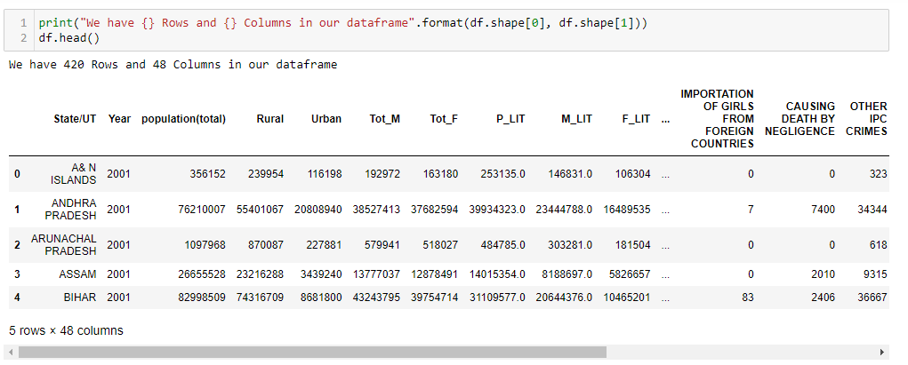

- Data Preprocessing Done
For the data pre-processing step, I checked through the dataframe for missing values 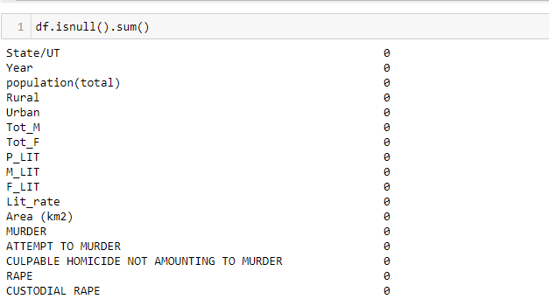

Checked the data type details for each column to understand the numeric ones
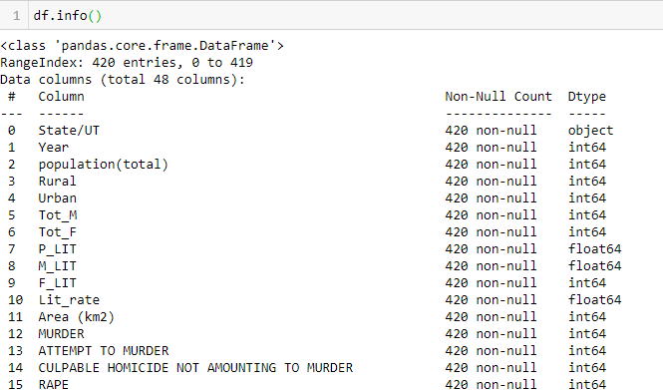

The various data null value filling on our data set are shown below with the code.Missing value found in 3 columns- total crime against women, Total crimes against STs, Total crime against children.
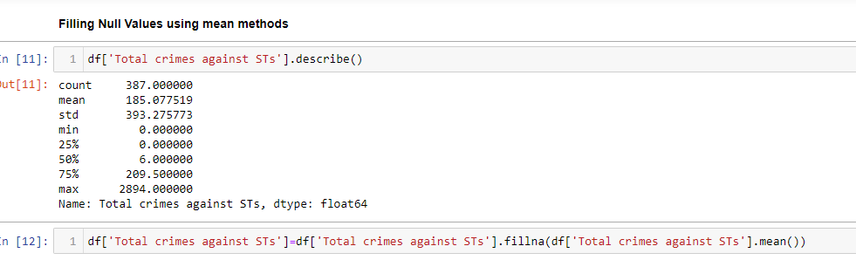

I then used the “describe” method to check the count, mean, standard deviation, minimum, maximum, 25%, 50% and 75% quartile data
Code:
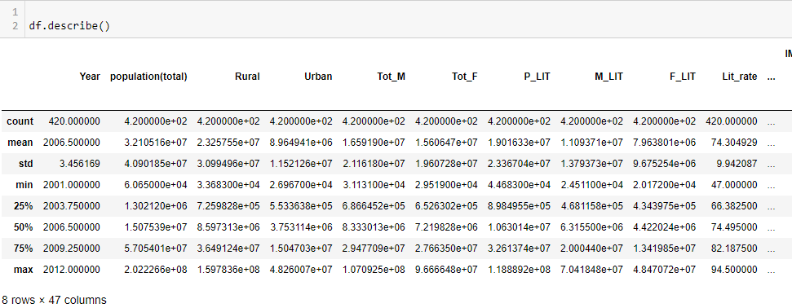
- Visualization
Let’s start visualising the columns, here we starting with the Type of crime like , Murder, Rape, Robbery happened in each year
Code:
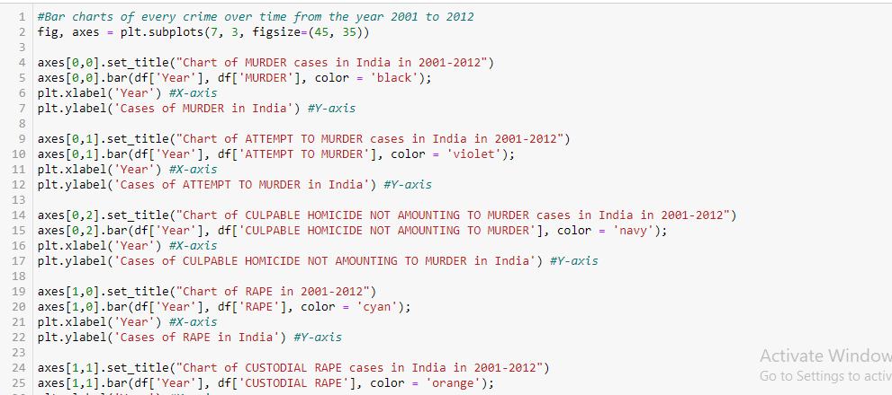
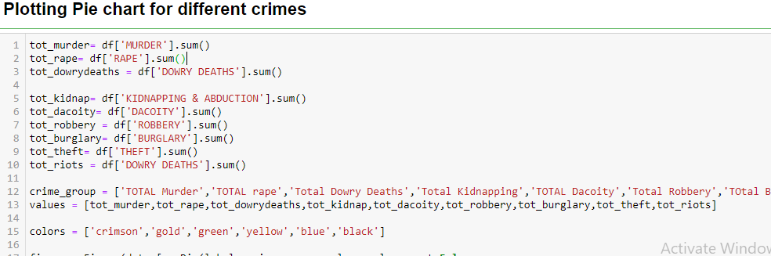
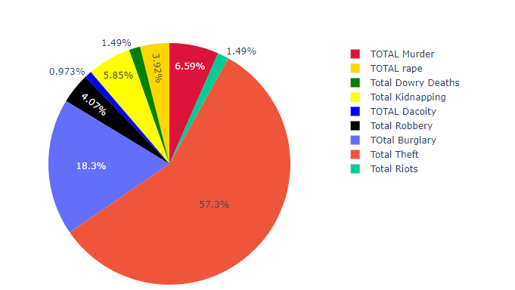
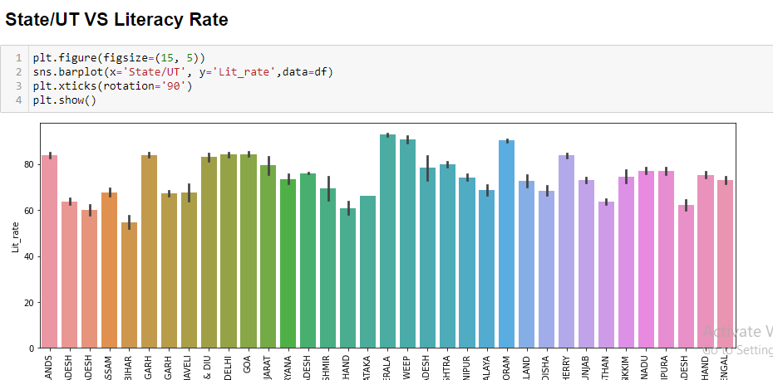
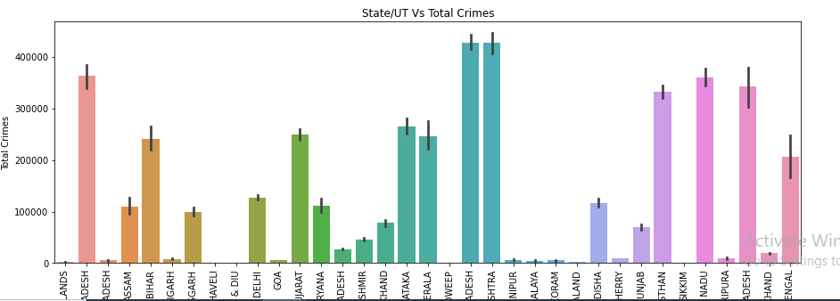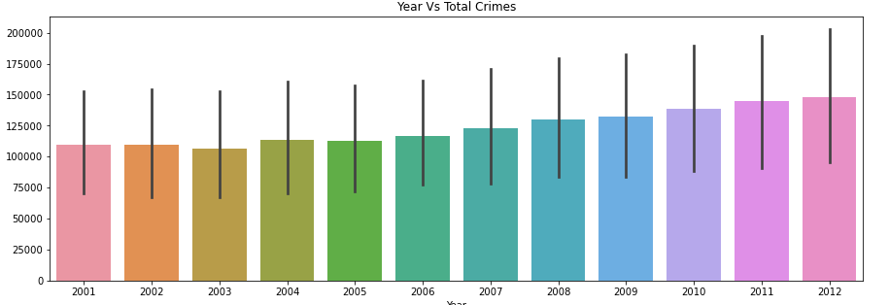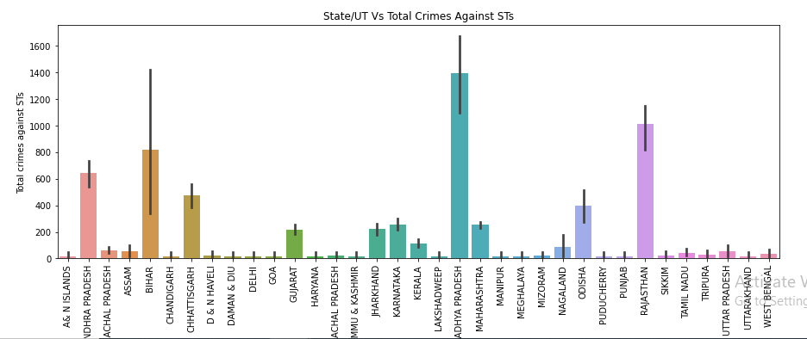
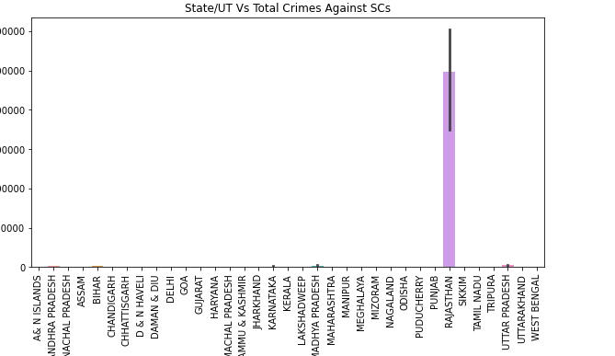

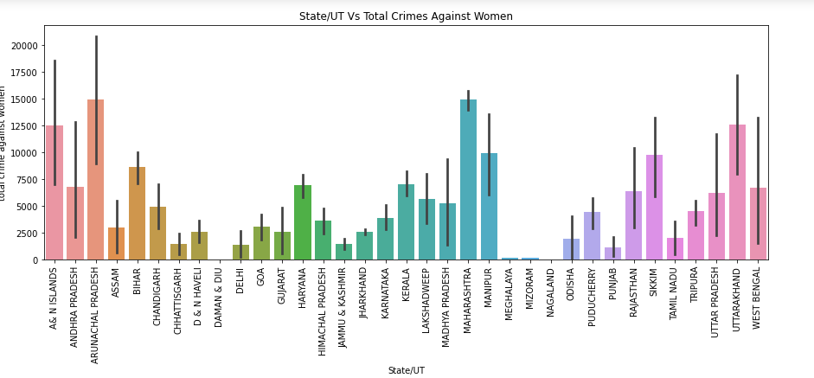
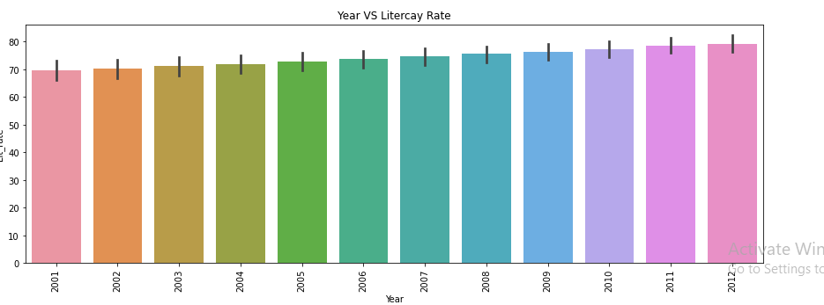
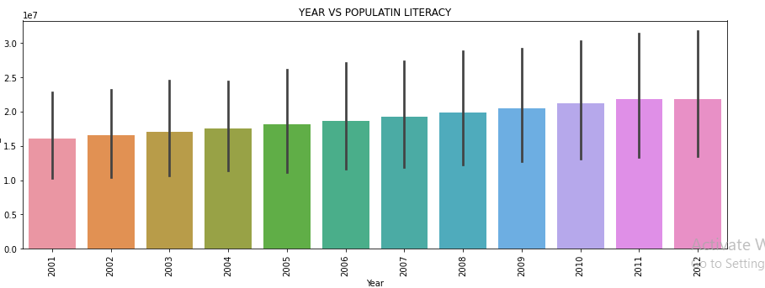
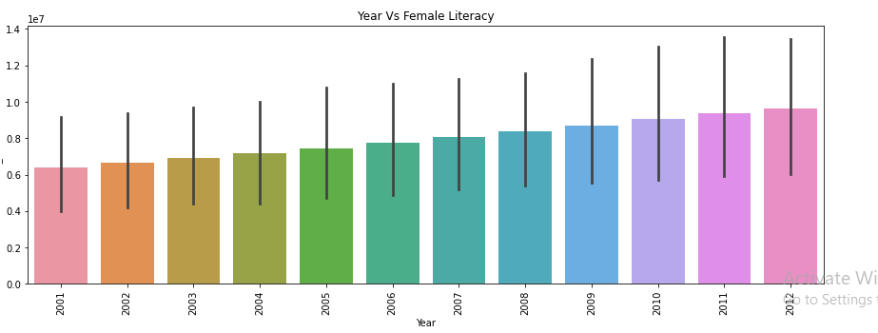

Similarly I analysed the State/UT vs Total crimes/Total crimes against SCs, /STs,Children

Plotted Line plotas well for Crime rate analysis for each state. 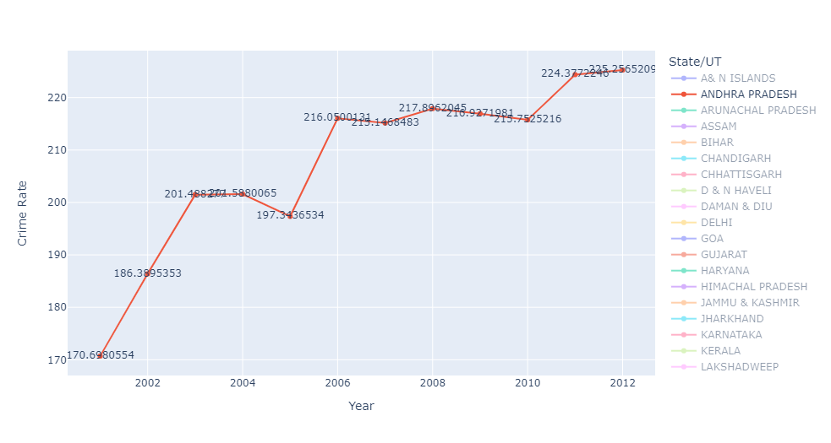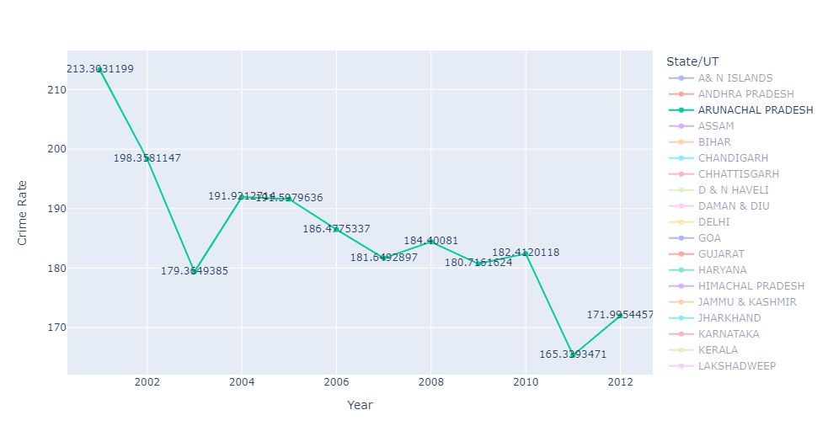 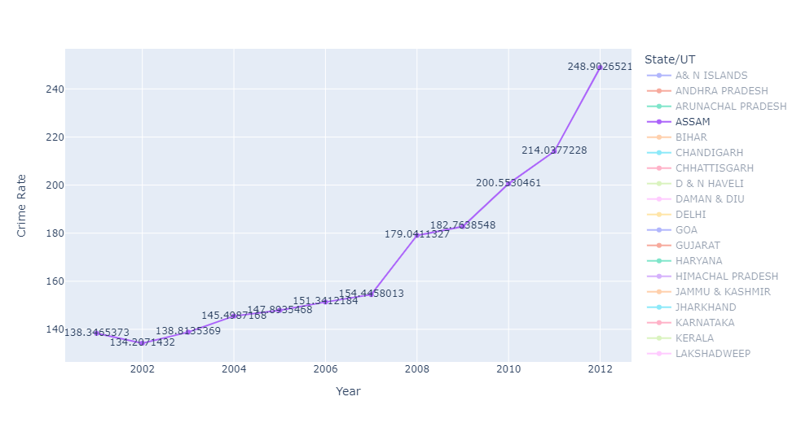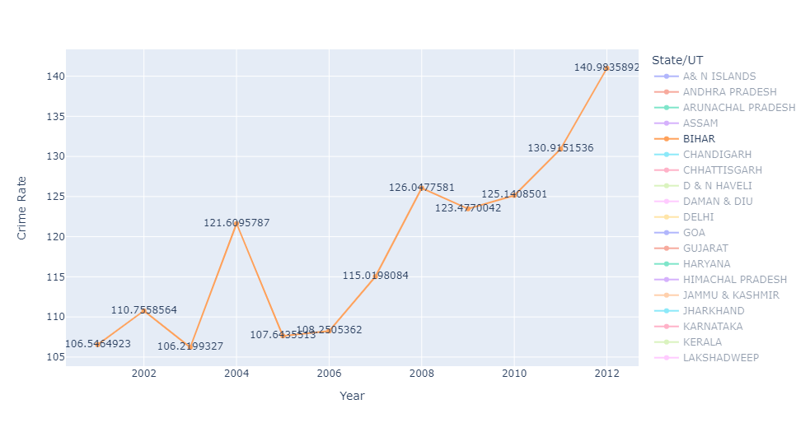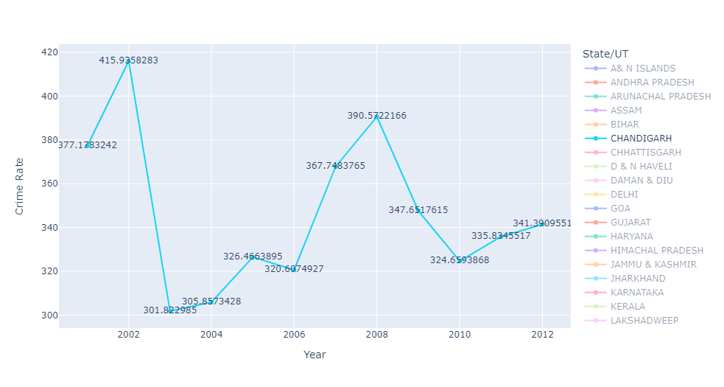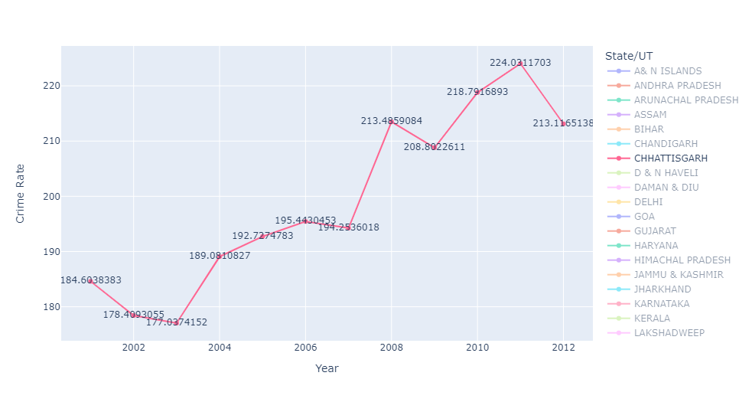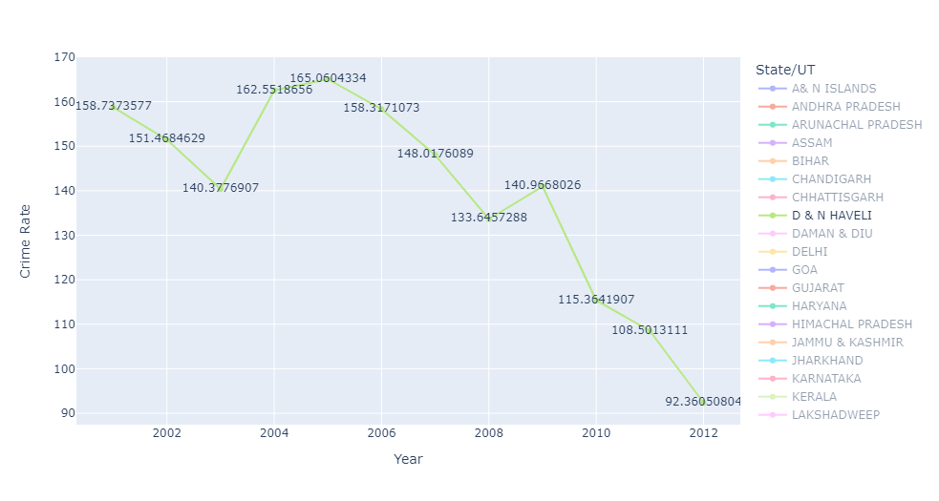

- Hardware and Software Requirements and Tools Used
Hardware technology being used.
RAM : 8 GB
CPU : AMD Ryzen 5 3550H with Radeon Vega Mobile Gfx 2.10 GHz
GPU : AMD Radeon ™ Vega 8 Graphics and NVIDIA GeForce GTX 1650 Ti
Software technology being used.
Programming language : Python
Distribution : Anaconda Navigator
Browser based language shell : Jupyter Notebook
Libraries/Packages specifically being used.
Pandas, NumPy, matplotlib, seaborn, scikit-learn, plotly
Phase 3- SQL
Insert Multiple record from the table given and extract the data as asked.
The CSV files that are used:
- 42_District_wise_crimes_committed_against_women_2001_2012
- 02_District_wise_crimes_committed_against_ST_2001_2012
- 01_District_wise_crimes_committed_IPC_2001_2012

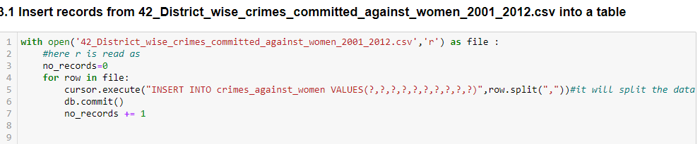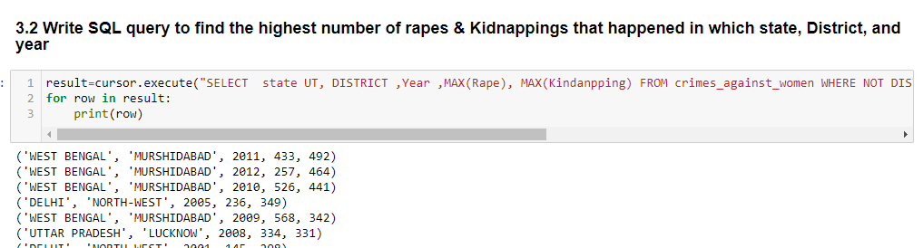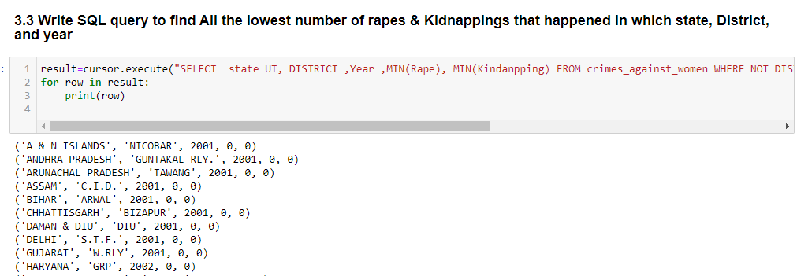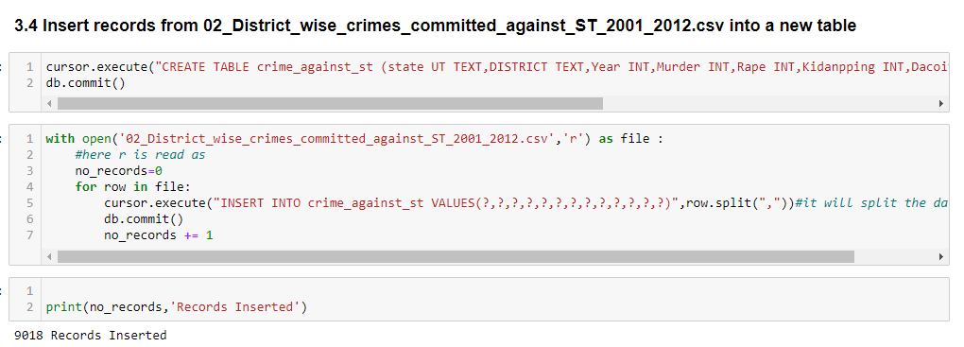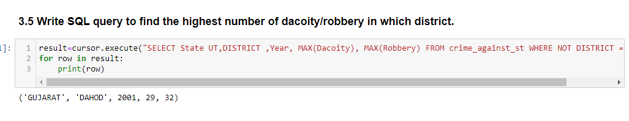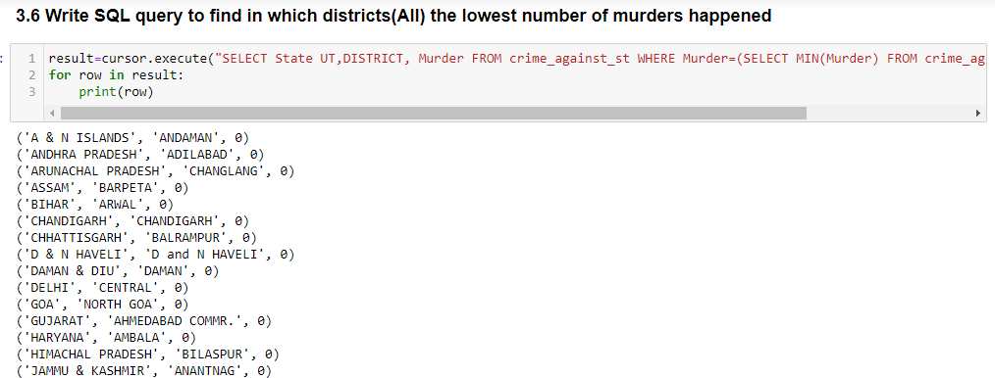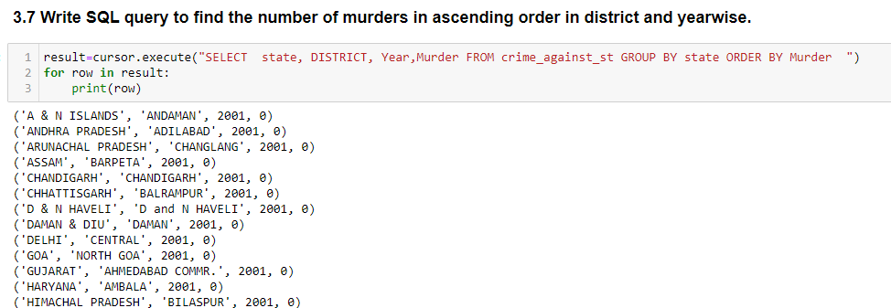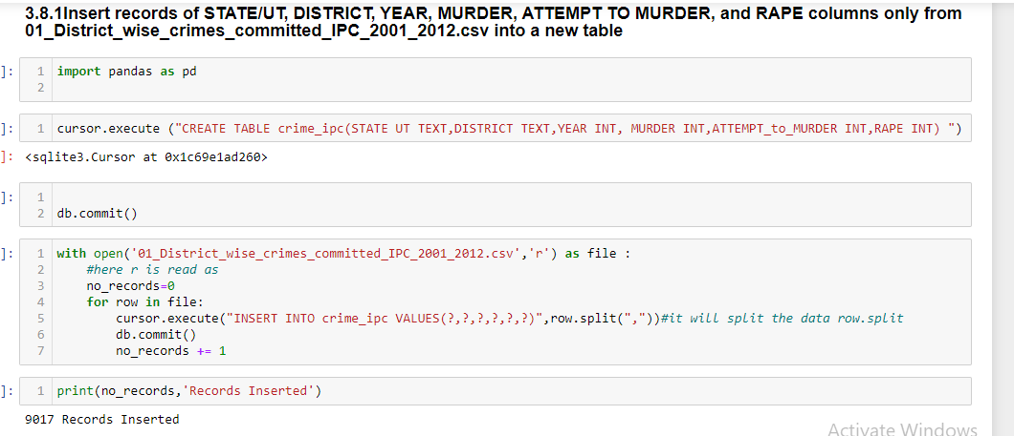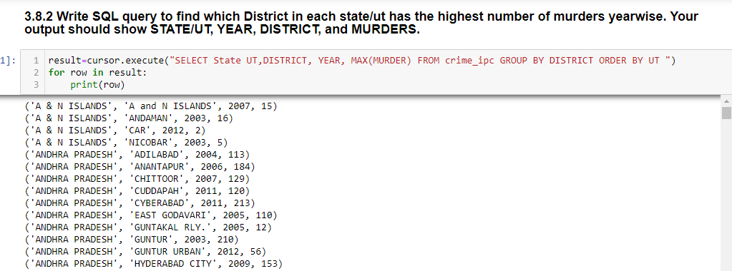
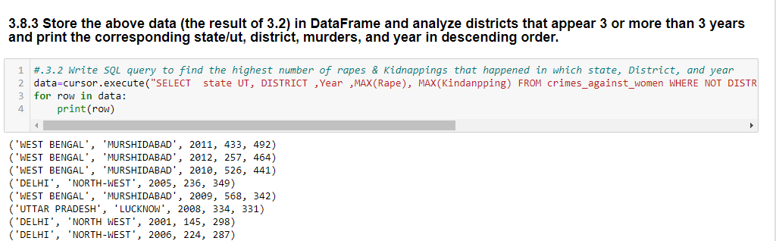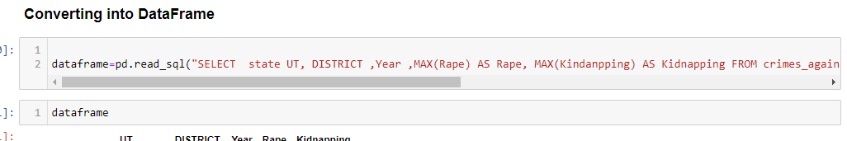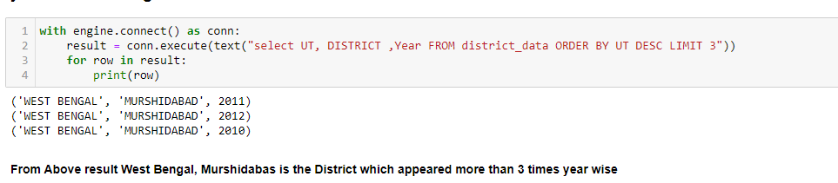
Here I anlysed the district with he help of Barplot.

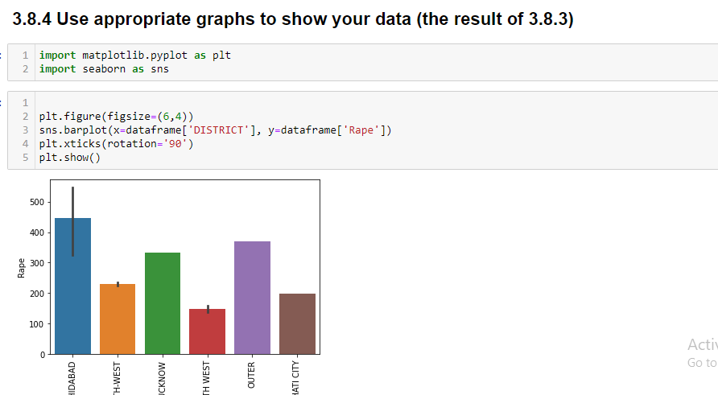
Phase 4
Unsupervised ML (Clustering)
You were given various crime datasets that contains all the DISTRICTS in each state and you were asked to provide the below data to the higher authorities for further action.
- I created one dataframe from multiple csv files
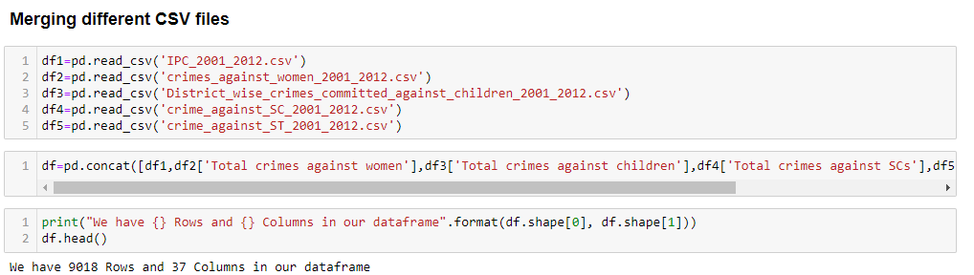
- Data Preprocessing-
- Checked for inforamtion of the columns using .info () method then checked for null values as well.
- Dropped few rows where District name was TOTAL or DELHI UT TOTAL as they were showing the whole sum of each crime head state wise which could have influenced the cluster so dropped
- Dropped few columns 'INSULT TO MODESTY OF WOMEN','KIDNAPPING AND ABDUCTION OF WOMEN AND GIRLS','CRUELTY BY HUSBAND OR HIS RELATIVES','IMPORTATION OF GIRLS FROM FOREIGN COUNTRIES','ASSAULT ON WOMEN WITH INTENT TO OUTRAGE HER MODESTY' columns from our dataset as it comes under Total crimes against women we already have that column in our dataset.

- Data Preparation before applying standardization
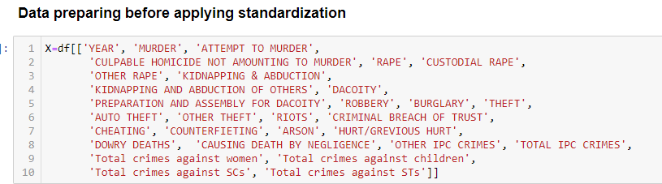

- Normalizing data for any type of clustering:
Normalizing the data is important to ensure that the distance measure accords equal weight to each variable. Without normalization, the variable with the largest scale will dominate the measure.Normalization is used to eliminate redundant data and ensures that good quality clusters are generated which can improve the efficiency of clustering algorithms.So it becomes an essential step before clustering as Euclidean distance is very sensitive to the changes in the differences
- Used Elbow method for finding the value of k 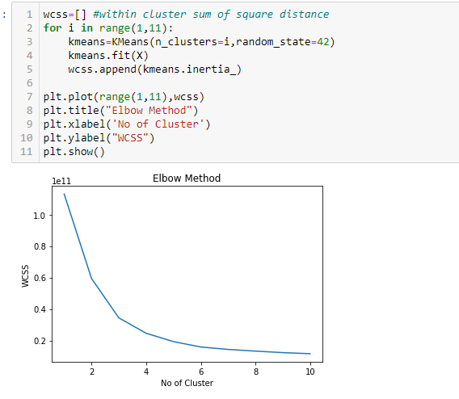

Choose k= 3 and made 3 cluster- and draw cat plot foe cluster and Draw Catplot and Scatter plot.
Code: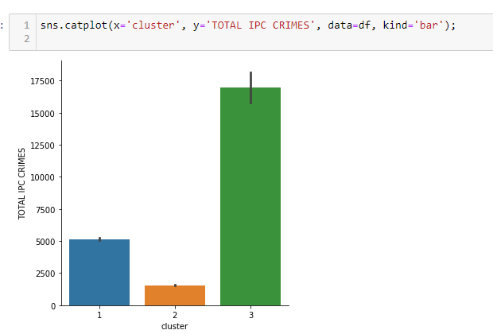
Also the scatter plot
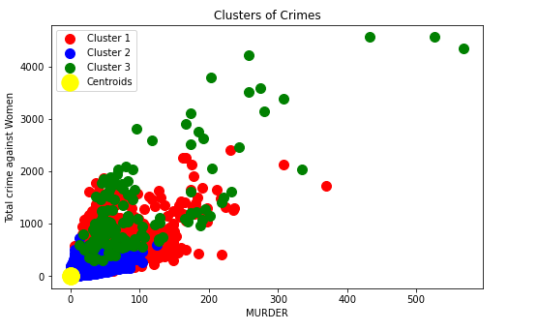
Analysed the data and assign the cluster name as given that is-
1. Sensitive Area's
2. Moderate Area's
3. Peaceful Area's"

Anslysed Each cluster and found the states with higher ,moderate and lower crime

1-Sensitive Area's
I generated count plots, bar plots, pair plots, heatmap and others to visualise the datapoint present in our column records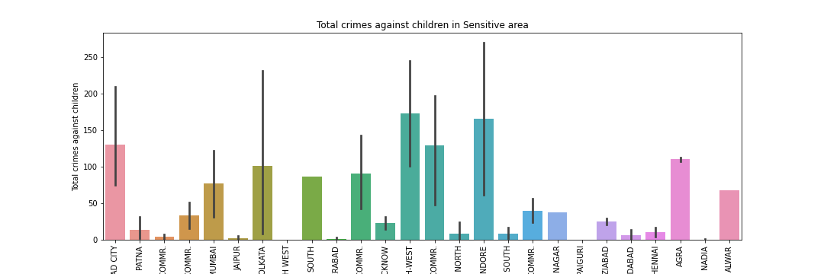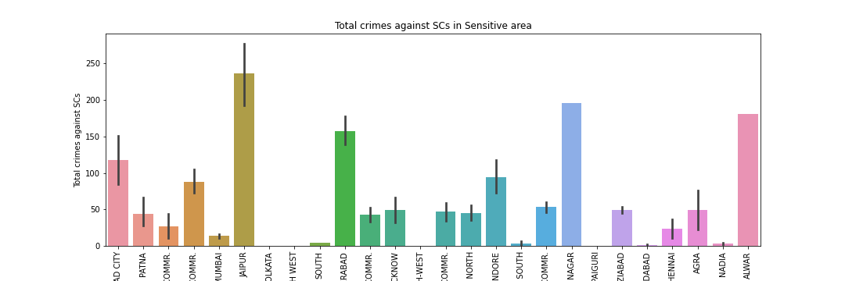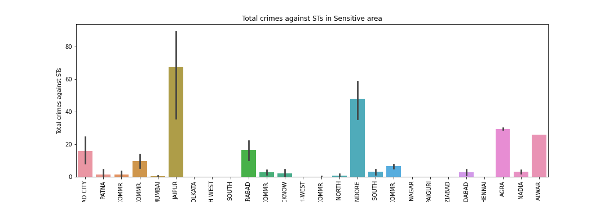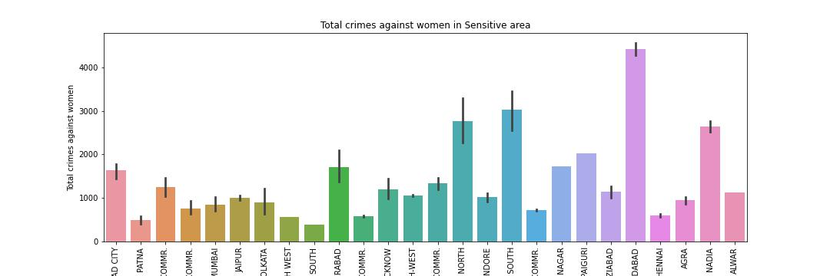
2-Moderate Area-
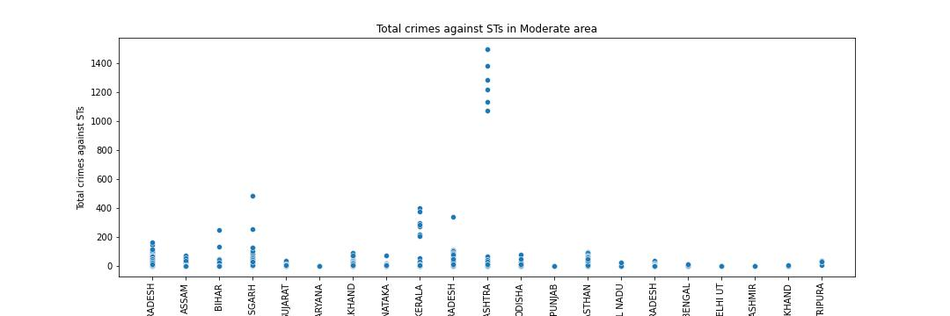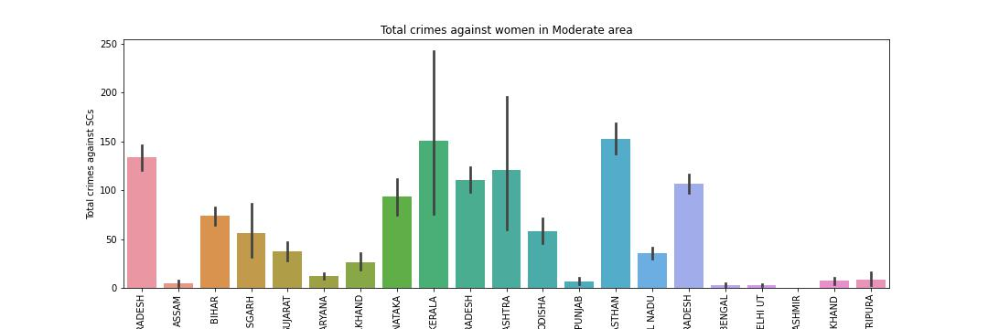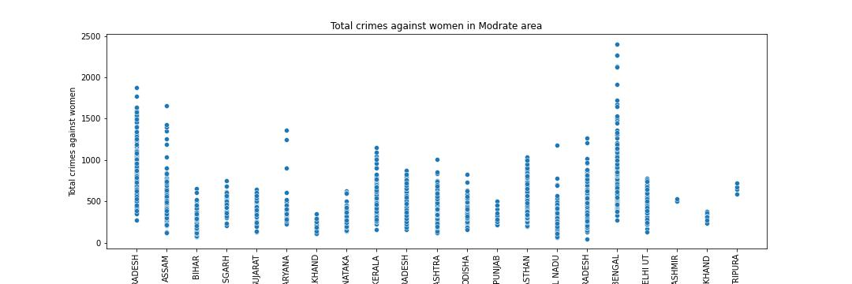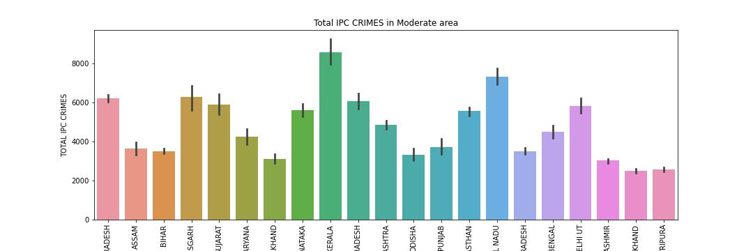
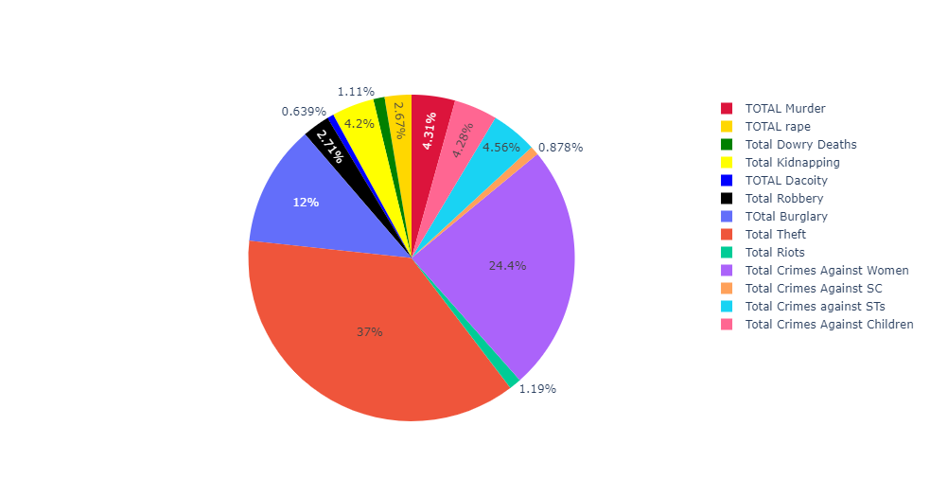
3-Peaceful Area-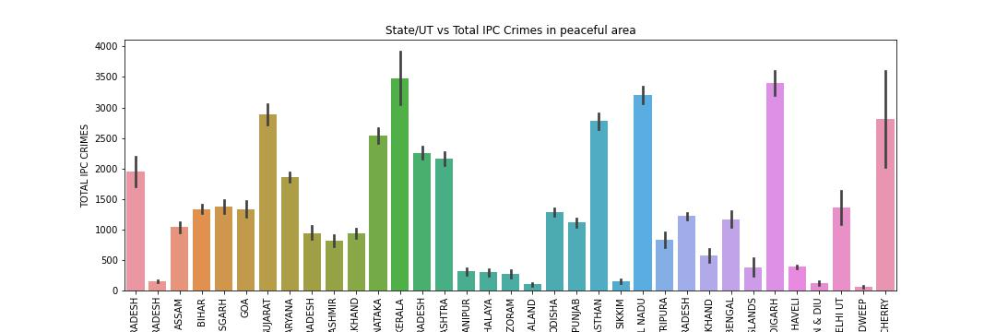 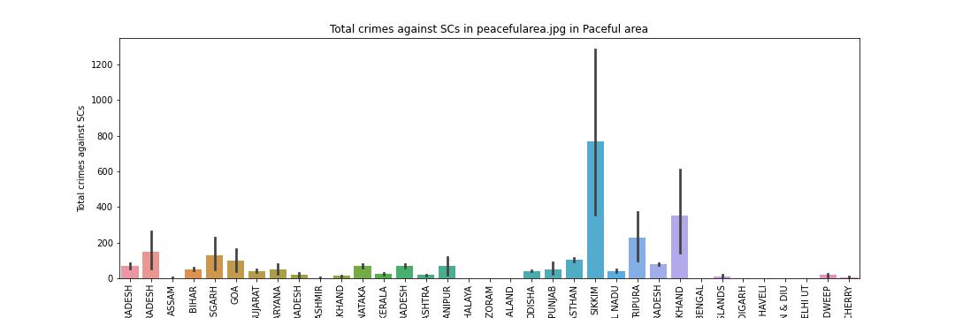 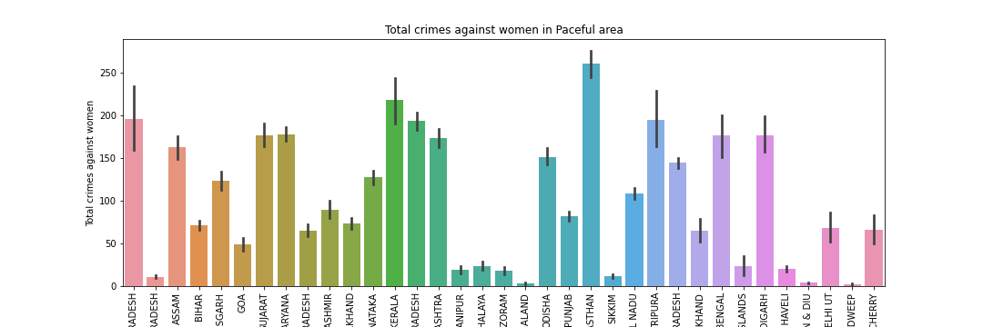 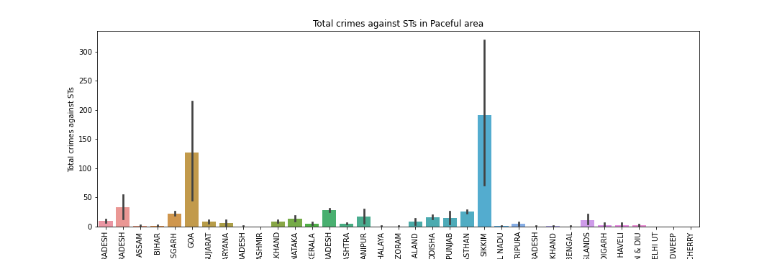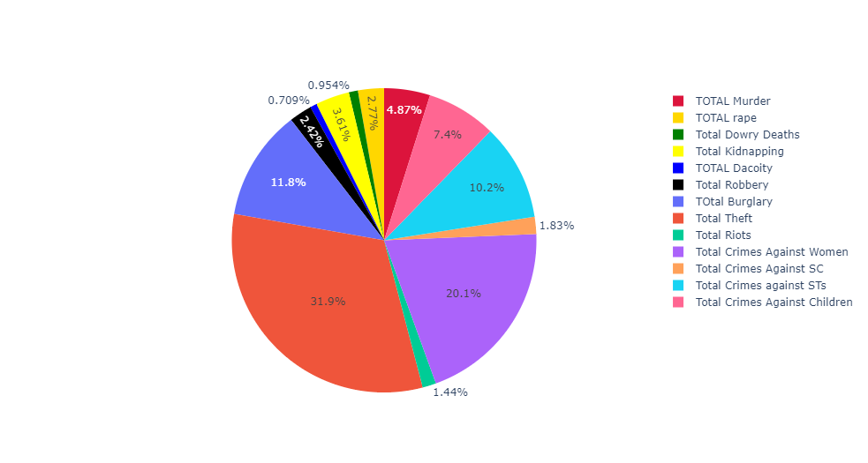

By using the different Barplots, scatter pots we analysed the clusters. Calculate the Score of the algorithm.
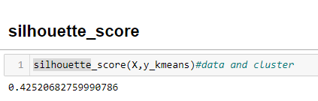

CONCLUSION
- Key Findings and Conclusions of the Study
After the completion of this project, we got an insight on how to collect data, pre-processing the data, analysing the data and building a model. First, we collected the used cars data from different websites like census, Kaggle, Wikipedia etc. We collected almost 420 of data which contained the population, literacy, area and other related features for states. Then the gathered data was combined in a single data frame and saved in a csv file so that we can open it and analyse the data. We did data cleaning, data pre-processing steps like finding and handling null values, removing words from numbers. Then we started EDA of the csv file that we created in first phase .Sql operations were done on agiven file and then phase 4 comes with the merging of different csv file and make a single data frame and Make 3 cluster and then analyse them and write down the observations.

Learning Outcomes of the Study in respect of Data Science
Visualization part helped me to understand the data as it provides graphical representation of huge data. It assisted me to understand the data more clearly..
- Limitations of this work and Scope for Future Work
The limitations I faced during this project were:
Data for Population , literacy, urban population, rural population were given for 2001 then data were available on web for 2011 so I calculated growth rate and applied that growth rate to find the population,rural populatin, literacy, male /female literacy , literacy rate for 2002 to 2010 which took a lot of time because 35 states were there and different columns were also there so it took approx 3-5 days for whole data collection part.
Future Work Scope:
Current algorithm is limited for the duration of 2001 to 2012 .


